Name: Karan Patel

Instructor: Professor Hatfield

Date: 2/21/2024

**Lab assignment 2: Develop a Program to Perform Base Conversion**

Source Code (Github): TODO GITHUB LINK

**Description: Decimal to Any Base Converter**

The Decimal to Any Base Converter is a versatile software tool designed to facilitate the conversion of positive decimal numbers into any base ranging from 2 to 35. Whether you're a student studying number systems or a professional needing to work with different bases, this software offers a user-friendly interface and robust functionality to meet your needs.

**Key Features:**

1. Decimal Input: Users can input positive decimal numbers of their choice, and the software will seamlessly convert them to the desired base.
2. Base Selection: The converter supports bases from 2 to 35, allowing users to select the base according to their specific requirements. Bases beyond 10 are represented using alphanumeric characters (A-Z) for single digits.
3. Efficient Conversion Algorithm: The software employs an efficient algorithm to ensure fast and accurate conversion of decimal numbers to the selected base.
4. Error Handling: The software includes robust error handling mechanisms to alert users in case of invalid input or unexpected errors during the conversion process.

**Example Usage:**

1. 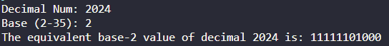
2. 
3. 
4. 
5. 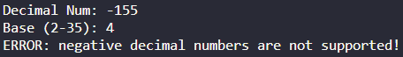
6. 
7. 
8. 

Whether you're converting numbers for mathematical calculations, programming tasks, or educational purposes, the Decimal to Any Base Converter provides a reliable solution for handling conversions with ease and precision.